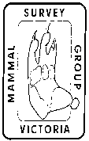 Mali Dunes Camp Brief Report….2 - 5 November 2013
This Melbourne Cup weekend camp was at ‘Mali Dunes’, a 620 ha property owned by Bernie Fox and Sue Hayman-Fox. It is located on Millers Rd, Yanac North, about 40 km north-west of Nhill. Vegetation consists of cleared areas with remnant pasture dominated by exotic grasses and evening primrose from past agricultural activity, mallee heathland with shrubs up to a height of 2 metres and mallee woodland up to a height of 5 metres. The natural vegetation has shown remarkable recovery after the area was chained and rolled for several decades until 1995. This is the fourth visit by MSGV to Mali Dunes, a site regularly surveyed every two years. Once again we would like to thank Bernie and Sue for their generous hospitality and guidance around this fascinating property.
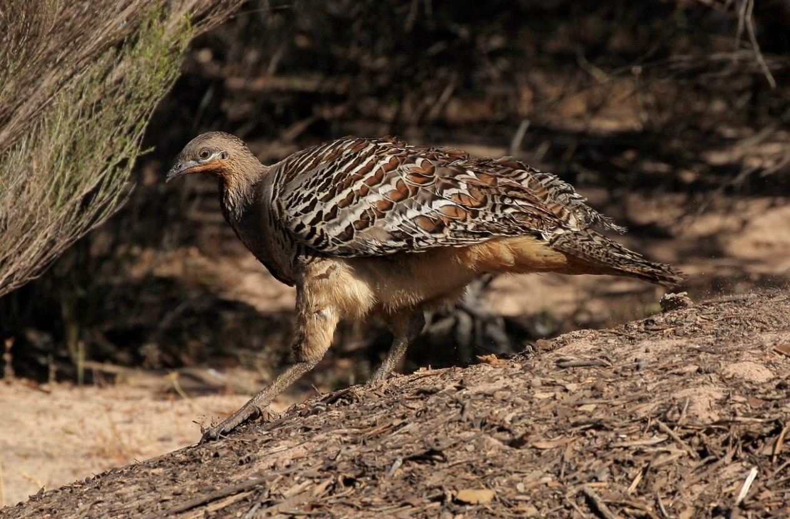
Male Malleefowl on mound near Pine T Dune - Photo Andrew McCutcheon
No cage or harp traps were set due to forecast cold evenings, which got as low as 1ºC. Almost all MSGV remote sensing cameras plus 6 privately owned by members, a total of 21 were set over three evenings. Results were poor compared to previous years with only a single record of a Mitchell’s Hopping Mouse captured by a camera set on Big Dune, a couple of rabbits, and a single Western Grey Kangaroo. A Southern Scrub Robin was recorded during the day on the House Dune just west of our camp.
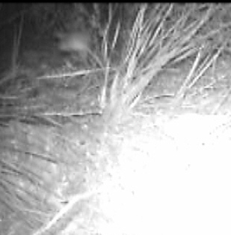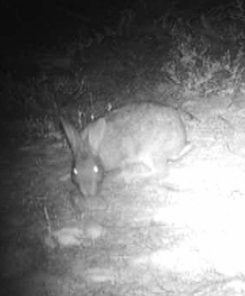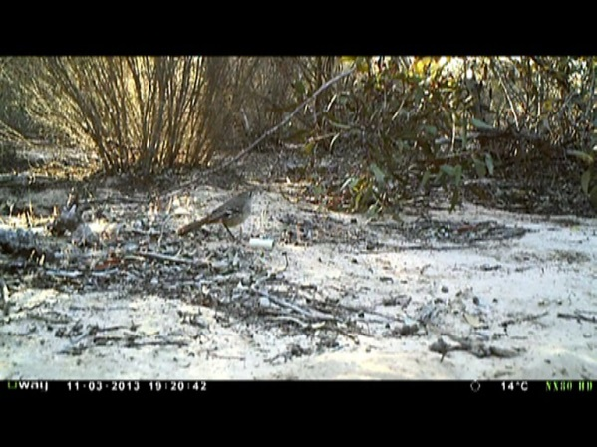
Mitchell’s Hopping Mouse Rabbit Southern Scrub-robin
- the blur in the top left hand corner
Other mammals seen or heard over the long weekend include a large number of Western Grey Kangaroos and rabbits. Of the 41 species of birds recorded Rufous Fieldwrens (reported to Birdlife Australia), a single White-fronted Honeyeater and Bernie’s ‘chooks’ the lovely Malleefowl were the highlight. All the other species recorded are what would be expected to occur in this reserve. Reptiles seen include two sightings of Rosenberg’s Monitor Varanus rosenbergi, which is at the very edge of its range of distribution, numerous Stumpy-tail Lizards, a Bearded Dragon and a few brief glimpses of Mallee Military and Painted Dragons. Invertebrates of note include a Golden Sun Moth Synemon sp. and an uncommon Skipper Butterfly, the Large Brown Skipper Motasingha trimaculata.
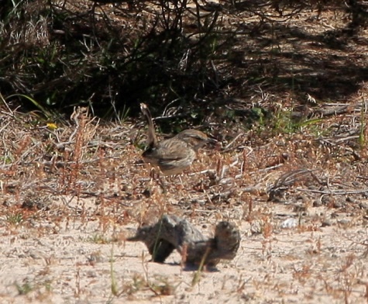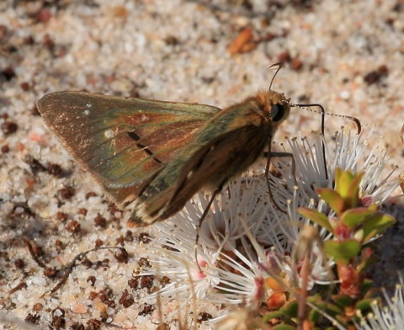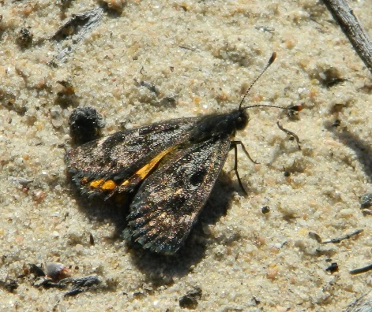
Rufous Fieldwren Large Brown Skipper Golden Sun Moth
Photos Andrew McCutcheon Photo Kathy Zonnevylle

Andrew McCutcheon – Mammal Survey Group of Victoria Inc.
WSIEAC Approval 22.11

